

ADOMAH BERNARD
IPMC College of Technology,
Box RR 701,
Ring Road,Accra.
20th May,2013.

The Manager,
,Accra.

Dear Sir,
Re:NETWORK AND SERVER ADMINISTRATION POSITION
I am writing to apply for a position as a System Engineer,as advertised on the internet throught a website.I have 2 years experience in providing,consulting,implementation and support services for IT projects and managements and providing solutions to clients as well.
I have very strong understanding on system engineering and business processes due to the experience gained during my education and my time at Website café and company limited ,where I was responsible for implementation of IT solutions(Installing,Configuring,Maintenance,Troubleshooting & Diagnotics of hardware/networking devices and Securing Data as well as Server Administration).I have excellent documentation,communication and interpersonal skills with the ability to liaise effectively and professional with individuals at all levels.My greatest assets are my ability to work with different personalities and adapt to different situations.
I am committed to customer satisfaction,providing timely and professional service in a friendly and positive manner.I have the ability to make systems more efficient,and my quick-thinking and can-do approach to problem-solving is a great asset that I would bring to the role of System Engineering in your team.I work well with others but am able to take autonomous roles in projects and maintain accountability for my results and productivity.I am also accustomed to travelling for work and am more than happy to continue doing so.
I believe I would be a great fit for this position and I would love the opportunity to work with your team.my resume and Cv is attached and I look forward to be able to discuss the position with you further.
Regards,
ADOMAH BERNARD

CURRICULUM VITAE
PERSONAL INFORMATION
NAME : ADOMAH BERNARD
DATE OF BIRTH : 20th MAY,1990
MARITAL STATUS : SINGLE
NATIONALITY : GHANAIAN
RELIGION : CHRISTIAN
LANGUAGES : ENGLISH & TWI
CONTACTS : 0547429214/0241172786
EMAIL : bernardadoma@yahoo.com
WEBSITE : www.bernardadomah.yolasite.com
HOBBIES : READING,RESEARCH & BROWSING
EDUCATION
SCHOOL DATE CERTIFICATION
1.DORMAA SENIOR HIGH SCHOOL 2006-2008 W.A.S.S.C.E
2.ALLNATIONS UNIVERSITY COLLEGE 2010-2011 CERTIFICATION
(INFORMATION & COMMUNICATION TECHNOLOGY)
3.IPMC COLLEGE OF TECHNOLOGY 2012-2013 PROFESSIONAL IN SYSTEM ENGINEERING
(HARDWARE,NETWORKING & LINUX FUNDAMENTALS)
4.IPMC COLLEGE OF TECHNOLOGY 2013-2014 ADVANCED IN SYSTEM ENGINEERING
(MCITP & LINUX ADMINISTRATION)
WORK EXPERIENCE
COMPANY DATE TITLE
Website café and company limited 2012 IT Manager/system administrator,
Café Attendant.
* Job description: Installing,Configuring,Maintenance,Troubleshooting,Diagnotics of Hardware/Networking devices,Server Administration as well as securing Data and providing services & solutions to customers.
SKILLS AND ABILITIES
1.Ability to make systems more efficient as well as providing and implementing IT solutions.
2.Strong understanding of System Engineering and business processes in terms of IT management.
3.Expert in computer Hardware,Networking,Server Administration,Cisco routing and many more.
4.Excellent documentation,communication and interpersonal skills with individuals at all levels.
5.Well organized,eager to learn and pro-active,competitive attitude and can thrive under pressure.
REFEREES
1.MR. YUSSIF MOHAMMED 2.MR.BRIGHT OPOKU 3.MR.KWAME AGYEI
SAL CONSULT COMPANY WEBSITE CAFÉ & COMPANY LTD. IPMC GHANA
DWORLOR,ACCRA. DANSOMAN,ACCRA. RING ROAD,ACCRA.
TEL:0244655648 TEL:0206124467 TEL:0244983508
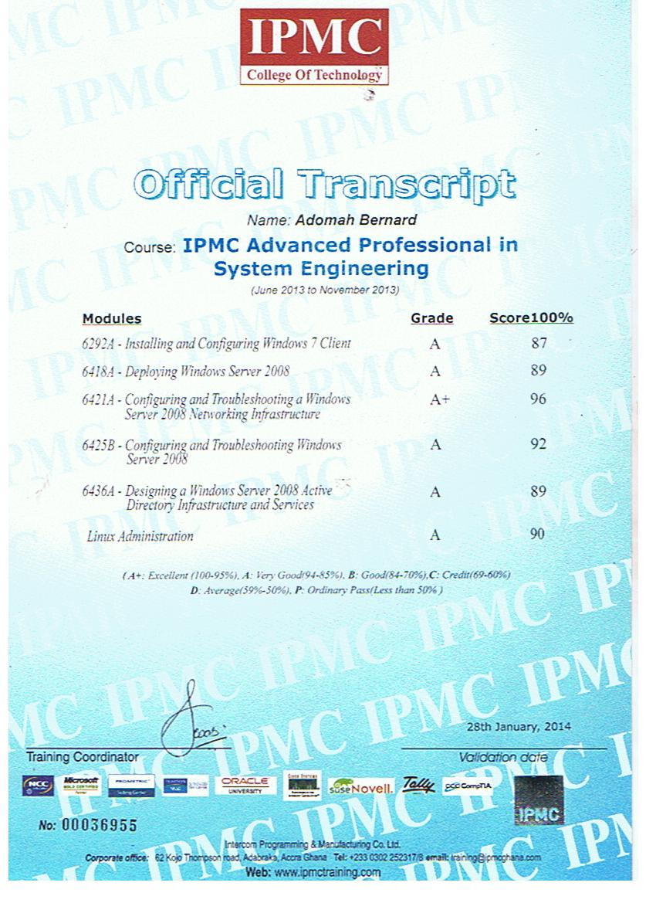
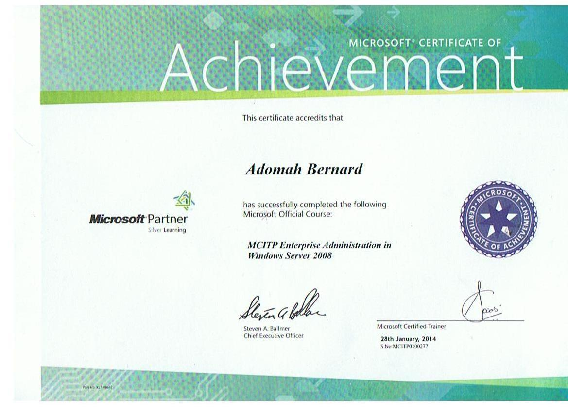
For more informations about my certification,please you visit my website;
www.bernardadomah.yolasite.com

